**Installing influxDB service in ubuntu(.amd):**

**$ wget https://dl.influxdata.com/influxdb/releases/influxdb2-2.0.4-amd64.deb**

--2021-04-23 13:10:36-- https://dl.influxdata.com/influxdb/releases/influxdb2-2.0.4-amd64.deb

Resolving dl.influxdata.com (dl.influxdata.com)... 13.227.220.77, 13.227.220.4, 13.227.220.83, ...

Connecting to dl.influxdata.com (dl.influxdata.com)|13.227.220.77|:443... connected.

HTTP request sent, awaiting response... 200 OK

Length: 47007766 (45M) [application/octet-stream]

Saving to: ‘influxdb2-2.0.4-amd64.deb’

influxdb2-2.0.4-amd 100%[===================>] 44.83M 8.95MB/s in 5.2s

2021-04-23 13:10:43 (8.63 MB/s) - ‘influxdb2-2.0.4-amd64.deb’ saved [47007766/47007766]

**$ sudo dpkg -i influxdb2-2.0.4-amd64.deb**

[sudo] password for sush:

Selecting previously unselected package influxdb2.

(Reading database ... 182139 files and directories currently installed.)

Preparing to unpack influxdb2-2.0.4-amd64.deb ...

Unpacking influxdb2 (2.0.4) ...

Setting up influxdb2 (2.0.4) ...

Created symlink /etc/systemd/system/influxd.service → /lib/systemd/system/influxdb.service.

Created symlink /etc/systemd/system/multi-user.target.wants/influxdb.service → /lib/systemd/system/influxdb.service.

**Installing Infux and influxd UI:**

1**)Download influxDB for Linux**

**$ tar xvzf /home/sush/Downloads/influxdb2-2.0.4-linux-amd64.tar.gz**

influxdb2-2.0.4-linux-amd64/LICENSE

influxdb2-2.0.4-linux-amd64/README.md

influxdb2-2.0.4-linux-amd64/influx

influxdb2-2.0.4-linux-amd64/influxd

**2)Setting environmental variables**

**$ sudo cp influxdb2-2.0.4-linux-amd64/{influx,influxd} /usr/local/bin/**

3**)Start and check the status of Server:**

**~$ sudo service influxdb start**

**$ sudo service influxdb status**

● influxdb.service - InfluxDB is an open-source, distributed, time series database

Loaded: loaded (/lib/systemd/system/influxdb.service; enabled; vendor preset: enabled)

**Active: active (running)** since Fri 2021-04-23 13:22:57 IST; 16s ago

Docs: https://docs.influxdata.com/influxdb/

Main PID: 35942 (influxd)

Tasks: 8 (limit: 9451)

Memory: 41.7M

CGroup: /system.slice/influxdb.service

└─35942 /usr/bin/influxd

Apr 23 13:23:00 sush-virtual-machine influxd[35942]: ts=2021-04-23T07:53:00.814719Z lvl=info msg="Using data dir" log_id=0TgRKYSl000 service=storage-engine service=store path=/var/lib/influxdb/engine>

Apr 23 13:23:00 sush-virtual-machine influxd[35942]: ts=2021-04-23T07:53:00.814811Z lvl=info msg="Compaction settings" log_id=0TgRKYSl000 service=storage-engine service=store max_concurrent_compactio>

Apr 23 13:23:00 sush-virtual-machine influxd[35942]: ts=2021-04-23T07:53:00.814825Z lvl=info msg="Open store (start)" log_id=0TgRKYSl000 service=storage-engine service=store op_name=tsdb_open op_even>

Apr 23 13:23:00 sush-virtual-machine influxd[35942]: ts=2021-04-23T07:53:00.814854Z lvl=info msg="Open store (end)" log_id=0TgRKYSl000 service=storage-engine service=store op_name=tsdb_open op_event=>

Apr 23 13:23:00 sush-virtual-machine influxd[35942]: ts=2021-04-23T07:53:00.814876Z lvl=info msg="Starting retention policy enforcement service" log_id=0TgRKYSl000 service=retention check_interval=30m

Apr 23 13:23:00 sush-virtual-machine influxd[35942]: ts=2021-04-23T07:53:00.814890Z lvl=info msg="Starting precreation service" log_id=0TgRKYSl000 service=shard-precreation check_interval=10m advance>

Apr 23 13:23:00 sush-virtual-machine influxd[35942]: ts=2021-04-23T07:53:00.814918Z lvl=info msg="Starting query controller" log_id=0TgRKYSl000 service=storage-reads concurrency_quota=10 initial_memo>

Apr 23 13:23:00 sush-virtual-machine influxd[35942]: ts=2021-04-23T07:53:00.815618Z lvl=info msg="Configuring InfluxQL statement executor (zeros indicate unlimited)." log_id=0TgRKYSl000 max_select_po>

Apr 23 13:23:01 sush-virtual-machine influxd[35942]: ts=2021-04-23T07:53:01.097876Z lvl=info msg=Starting log_id=0TgRKYSl000 service=telemetry interval=8h

Apr 23 13:23:01 sush-virtual-machine influxd[35942]: ts=2021-04-23T07:53:01.098397Z lvl=info msg=Listening log_id=0TgRKYSl000 transport=http addr=:8086 port=8086

**Installing telegraf Service:**

**$ wget https://dl.influxdata.com/telegraf/releases/telegraf_1.18.1-1_amd64.deb**

--2021-04-23 13:31:53-- https://dl.influxdata.com/telegraf/releases/telegraf_1.18.1-1_amd64.deb

Resolving dl.influxdata.com (dl.influxdata.com)... 13.227.220.83, 13.227.220.77, 13.227.220.106, ...

Connecting to dl.influxdata.com (dl.influxdata.com)|13.227.220.83|:443... connected.

HTTP request sent, awaiting response... 200 OK

Length: 25345152 (24M) [application/x-debian-package]

Saving to: ‘telegraf_1.18.1-1_amd64.deb’

telegraf_1.18.1-1_amd64.deb 100%[===============================================================================================================>] 24.17M 2.26MB/s in 16s

2021-04-23 13:32:10 (1.54 MB/s) - ‘telegraf_1.18.1-1_amd64.deb’ saved [25345152/25345152]

**$ sudo dpkg -i telegraf_1.18.1-1_amd64.deb**

Selecting previously unselected package telegraf.

(Reading database ... 219787 files and directories currently installed.)

Preparing to unpack telegraf_1.18.1-1_amd64.deb ...

Unpacking telegraf (1.18.1-1) ...

Setting up telegraf (1.18.1-1) ...

Created symlink /etc/systemd/system/multi-user.target.wants/telegraf.service → /lib/systemd/system/telegraf.service.

**Start Telegraf Servive: $ sudo service telegraf start**

**With InfluxDB running, visit** [**localhost:8086**](http://localhost:8086/)**.**

1. Click Get Started

#### [Set up your initial user](https://docs.influxdata.com/influxdb/v2.0/get-started/?t=Linux" \l "set-up-your-initial-user)

1. Enter a Username for your initial user.
2. Enter a Password and Confirm Password for your user.
3. Enter your initial Organization Name.
4. Enter your initial Bucket Name.
5. Click Continue.

**Configure Telegraf:**

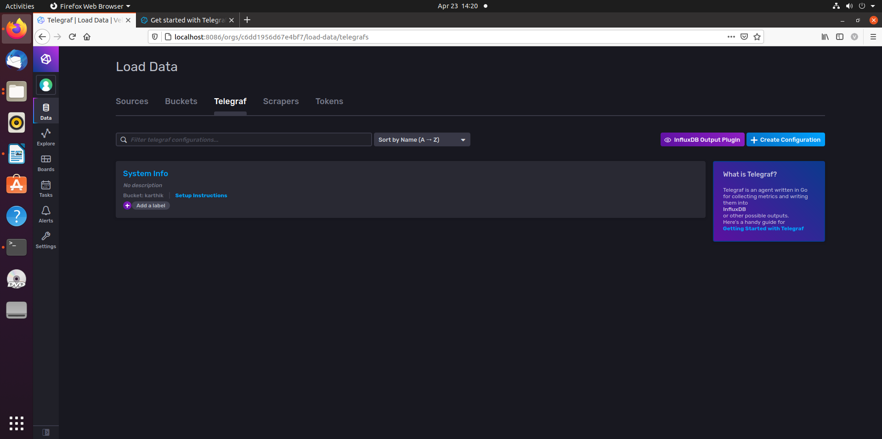

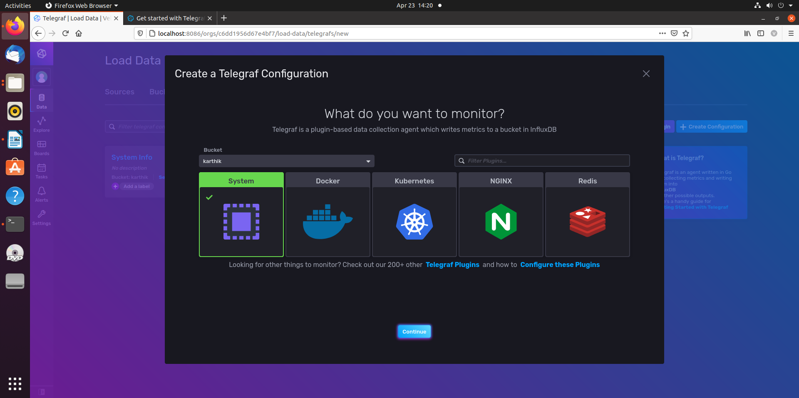**Select required Plugins:**

**Select The attributes:**

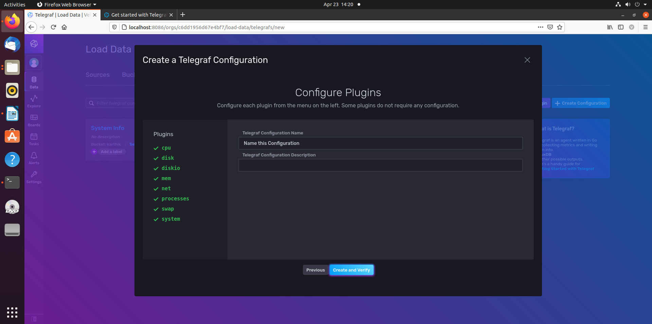

**Executing Query Digitally:**

